

Database requirement specifcation for Patient record and Status SYSTEM

University Of Guyana



Shemar Austin - 1024733

Dawyne jacobs - 1009761

Ameer Mohammed Yusuff - 1024039

Jared Rondell Watson - 1028651

Hueley Husbands - 1015938

USI# :1028651

Database Systems Design & Information Management Systems: CSE 2102 Sir Girendra Persaud

Table of Contents

1.0 General Information 2

Introduction 3

Purpose 3

Intended Audience 3

Project Scope 3

System Overview 3

2.0 Identification & Description 4

Previous /Current Systems 5

Disadvantages 5

Advantages of the proposed system 5

Product Perspective 5

System Characteristics 5

Functional Requirements 5

System Functional Requirements 6

Non-Functional Requirements 6

External Hardware 7

Relationship to other databases 7

3.0 System Application 8

System Testing 9

Deployment 9

4.0 Use Cases & Use Case Diagrams 10

Use Case Description 12

Data Flow Diagram 13

5.0 Conceptual Design 14

6.0 Logical Design 15

# 1.0

# GENERAL INFORMATION

# INTRODUCTION

This section introduces the system requirement specification for the Patient Record & Status Database.

# PURPOSE

The doctors of the male ward at the Georgetown Public Hospital Co-operation have multiple patients to deal with and little time to take and update information on each patient. This has brought about the idea to implement the Patient Record & Status Database.

The corporation has tasked us to build an online and offline database to manage patients and their ward information. This will help the documentation of patient data, while saving time, which can be used for paying attention to the patients in need.

# INTENDED AUDIENCE

* The proposed project is a prototype for patient management. The intended audience of partners for the specification of the Patient Record & Status Database include:
* Georgetown Public Hospital Co-operation:
* Data Management Teams
* Information Technology Staff
* Administrators of the Data Entry and Management team
* Chief Executive Officer

# PROJECT SCOPE

The purpose of the Patient Record & Status Database project is to ease data management at crucial times and to create a convenient and easy-to-use database for Data Entry Clerks. After the prototype, there will be multiple databases in the hospital all positioned at different wards. Above all, we hope to provide a speedy and user-friendly database.

# SYSTEM OVERVIEW

The project will be given to the male ward in the Georgetown Public Hospital Co-operation and have the project name “Patient Record & Status Database”. This database will be useful by saving resources and time. This database is currently under development

# 2.0

# IDENTIFICATION & DESCRIPTION

# PREVIOUS/ CURRENT SYSTEMS

The Corporation used a paper based system writing all information given to them

# DISADVANTAGES

The following are disadvantages of the paper based system

* It takes up a lot of time, causing doctors to be in and out of updating the information.
* It is complicated to keep all the important data in books.
* It can be very clustering taking up a lot of space.

# ADVANTAGES OF THE PROPOSED SYSTEM

The following are advantages of the Database system

* Easy to manage patient data.
* Can easily create reports and statistical analysis
* User interface easy to use
* Less time taking and manages space easily.

# PRODUCT PERSPECTIVE:

The Patient Record & Status Database system will store the following information:

* Patient Personal Data: This includes the patient’s name, any family information and contact information.
* Patient Status: It includes why the patient is in the ward and how the patient is.
* Impending Procedure: This includes any possible surgeries or any procedure that has to happen later down.
* Total Count: It includes the amount of patients in the ward.

# SYSTEM CHARACTERISTICS

# FUNCTIONAL REQUIREMENTS

Users of this system should be able to deliver and retrieve patient information at any given time. The system will be able to support two forms of user privileges: The Staff (Data Entry Clerk) and the Administrators. Clerks will have entry functions and the administrators will have access to both the entry functions and storage management functions.

The Staff should be able to

1. Interact with the application
2. Be able to Add Patient Information
3. Be able to schedule any pending procedures
4. Be able to update the status of the patient

The Administrator should be able to

1. View all patient’s information
2. View the doctors and staff taking care of the patient
3. Edit and Remove information
4. Generate Patient chart
5. Generate Status Chart
6. Generate Statistical Data

# SYSTEM FUNCTIONAL REQUIREMENTS

1. The system should be able to collect, store and return information about the patient.
2. The system should be all to keep count of all patients and any possible changes happening to the patient
3. The system should provide the administrators with a count of the patients inside the ward at the current time, along with their entry times
4. The system shall be able to update any past procedures automatically
5. The system should be able to add a Patient ID or Key code to each patient that enters automatically
6. The system should be able to create tables of statistical data after every 24 hours and send the information to the administrator.

# NON-FUNCTIONAL REQUIREMENTS

1. Usability

The system should be user friendly and have a well-structured and simple interface that can provide quick navigation

1. Security

The system will be open to any staff member, but the administrators will have a to enter by the use of a login screen

1. Performance

The performance and speed of the system should be fast and systematic in the updating of the database. This means that the system should be real time and easy to update

1. Accessibility

The system should be available to any computer with database installed.

1. Data Retention

The system should be able to store any information inputted, whether to be used right away, or later down

1. Availability

The system will operate 24 hours a day, 7 days a week

1. Maintenance

The system should be maintained and serviced monthly in order for the best of its ability. Systems will be maintained by IT personnel

1. Disaster Recovery

The system will be able to recover data from any problem and back up data every 24 hours

1. Error Handling
2. The system should be able to discover and point out errors. Self-correcting will only apply to statistical data

# EXTERNAL HARDWARE

The database will interact with:

* Clerk/ Admin Hardware

Both the Data Entry Clerks & Administrators will be equipped with a personal computer to perform their tasks.

* Networks.
* Internet- Access for the database to be backed up and updated on online servers.
* Local Area Networks- The database will be made on a LAN server for an easier flow of data from one computer to another.

# RELATIONSHIP TO OTHER DATABASES

This database can collect data from database in the public outstations

# 3.0

# SYSTEM APPLICATION

# SYSTEM TESTING

The team will test the system and checks for error, bugs and any discrepancies.

DEPLOYMENT

This is the final stage of development.

**F**EEDBACK & MAINTENANCE

This is the most important stage. The database will be maintained by a personnel checking the database ever month.

# 4.0

# USE CASES & USE CASE DIAGRAMS

In the Patient Record & Status Database, there will be two actors: The Admin and The Data Entry Clerk

Figure 1.

ALL ACTORS



DATA ENTRY CLERK



ADMINISTRATORS

ADD/REMOVE PATIENT INFORMATION



UPDATE PATIENT STATUS

UPDATE PROCDEURES

DATA ENTRY CLERK

Figure 2: Data Entry Clerk’s use cases



ADD/REMOVE PATIENT INFORMATION

UPDATE PROCDEURES

GENERATE STATISTICAL DATA AND CHARTS

ADMINISTRATORS

UPDATE PATIENT STATUS

Figure 3: Administrators’ use cases

# USE CASE DESCRIPTION

Use Case Scenario 1: Add/ Remove information

* The Data Entry Clerk wishes to enter and update information on a pre-existing patient
* Actor: Data Entry Clerk
* Scope: Patient Record & Status Database

|  |  |
| --- | --- |
| Actor: Data Entry Clerk | Patient Record & Status Database |
| 1. DEC opens the database | 1. The system show the main database |
| 1. DEC enters information on patient | 1. Databases sees if info is valid and stores it |
| 1. DEC removes information on patient | 1. Databases clear information and updates the data |

Table 1. Use Case: Add, Remove and update Patient’s Information

Use Case Scenario 2: View information and create Statistical Charts & Data

* The Administrator would like to view all patient information and write statistical reports
* Actor: Administrator
* Scope: Patient Record & Status Database

|  |  |
| --- | --- |
| Actor: Administrator | Patient Record & Status Database |
| 1. Admin opens the database | 1. System shows login page |
| 1. Enters username and password | 1. System verifies login info and enters the main database screen |
| 1. Enter information on patient | 1. Database sees if info is valid and stores it |
| 1. Removes information on patient | 1. Database clears information and updates the data |
| 1. Chooses “Export” to excel | 1. Database carries data to Microsoft excel to be statistically viewed |

Table 2. Use Case: Add, remove, update information and Export data to viewed and modified

# DATA FLOW DIAGRAM

This diagram is used to show the flow of data amongst three primary nodes; The Data Entry Clerk, Administrators and the Main Storage

PATIENT DATA

DATA ENTRY CLERKS

ADMINISTRATORS

PATIENT RECORD & STATUS DATABASE

MAIN STORAGE

SECONDARY STORAGE

# 

# 5.0 CONCEPTUAL DESIGN

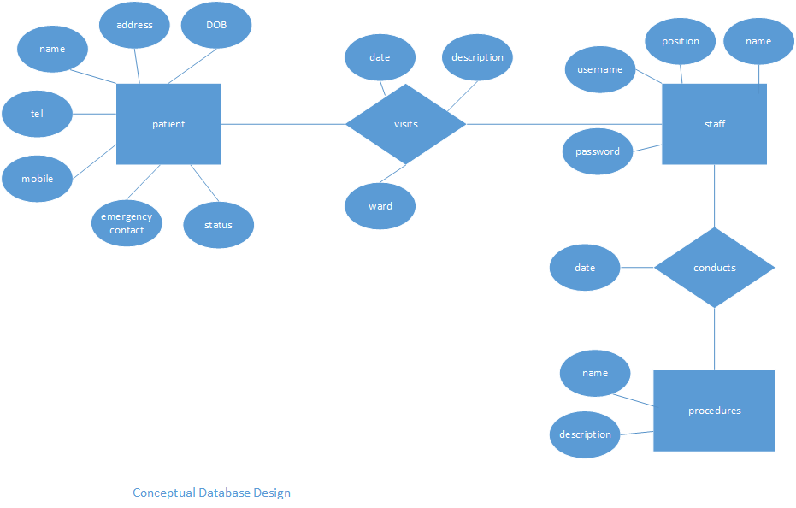

# 6.0 LOGICAL DESIGN

